**Seminar at Center for Advanced Technology, Laboratory of Applied Biotechnology  
Adam Mickiewicz University, Poznan, 20 April 2023**  
  
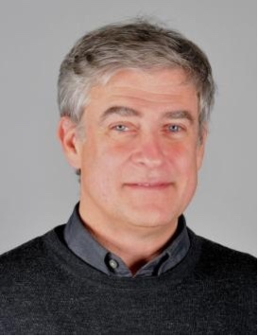

**Prof. Florian Rüker**  
  
BOKU - Universität für Bodenkultur, Wien  
University of Natural Resources and Life Sciences, Vienna  
  
Department of Biotechnology  
Institute of Molecular Biotechnology   
  
Co-founder of F-star Therapeutics

**Antibodies the other way round**

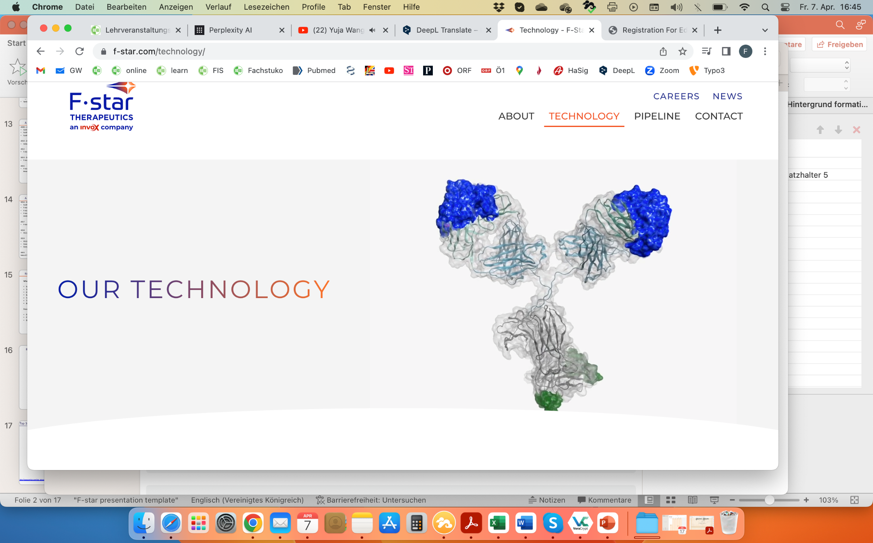

Bispecific monoclonal antibodies are of increasing importance in the treatment of different diseases like autoimmune disorders or cancer. We have developed a way to engineer additional antigen binding sites into the Fc part of a monoclonal antibody (mAb). These antigen binding Fc parts, also called Fcabs (Fc antigen binding) can be used as standalone molecules, as well as building blocks in complete mAbs, creating bispecific, tetravalent antibodies, also called mAb2. In my presentation, I will explain how this technology works, how it can be applied, and how the company F-star Therapeutics has developed since 2006.

